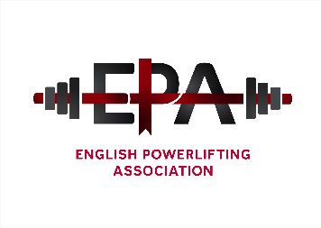

The English Powerlifting Association - Notice of Annual general Meeting for 2025
The meeting will be held at Moulton College, Gate 4 site, Pitsford Lane Moulton, Northamptonshire NN3 7QL Sunday 1st February 2026 at 11.00am.
Please forward to the Secretary any nominations for officer positions and written reports by the 5thJanuary 2025, also any notices of motions. Those for the British AGM are for discussion only.

AGENDA;
1. Members present;
2. Apologies
3. Acceptance of previous AGM minutes (2/2/2025).
4. Officer & divisional reports (Written only)
5. Election of Officers (currently)
Position | Officer
President | Fred McKenzie
Chairman | Richard Parker
Assistant Secretary | Lottie Hall
General Secretary | Kevin Jane
Treasurer | Jenny Hunter
Assistant treasurer | Lottie Hall
Sponsorship secretary | Fred McKenzie
Championship secretary | Adam Fosbrook
Development officer | Vacant
Selection secretary (head coach) | James Taylor (Interim)
Records Officer | Craig Wilkins
Web Master | Matthew Parker
Director for England | Kevin Jane
Social media officer | Matthew Parker
Social Media Assistant | Nash Hunter

7. Divisional representatives: Currently
DIVISION | REPRESENTATIVE
East Midlands | Siobhan Taylor
North Midlands | Jenny Sherwood
South Midlands | Ashraf Alhasan
West Midlands | Catherine Shamel
Greater London | Joy Nnamani
North West | Bryn Evans
South East | Mick Ellender
South West | Emily Bennett
Yorkshire North East | Matthew Dempsey

7. Championship Dates
All England Bench press, 4/5th April 2026, Moulton College Northampton. Bids required for England Women’s and men’s All England, English Sub junior/Junior championships, & English Masters Championship
Home nations I.O.M, Commonwealth Championships - Winnipeg, Canada 17-27 September 2026. Small Nations - Luxembourg February 2026.
8. Council meeting dates
9. Notices of Motion (EPA)
10. Notices of motion for British Powerlifting AGM discussion only)
11. Membership rebates
12. Any other business

.

