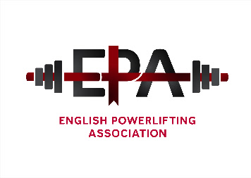

The English Powerlifting Association - Annual general Meeting for 2019.
The meeting will be held in room P8, Thorpe Centre, Gate 4, Moulton College, Pitsford Lane, Northampton NN3 7QL on Saturday 1st February 2020 commencing at 10.30am.
- All Notices of Motion, (for discussion only)nominations for officer positions and officer reports should be in written format and sent to the Secretary by the 3rd January 2019.
AGENDA;
- Members present
- Apologies
- Acceptance of previous AGM minutes (26/1/2019).
- Officer reports Written only)
- Election of Officers (currently)
Position | Officer
President | Fred McKenzie
Chairman | Richard Parker
General Secretary | Kevin Jane
Treasurer | Fred Sterry
Assistant treasurer | Doreen Dowsett
Sponsorship secretary | Fred McKenzie
Championship secretary | Kevin Jane
Selection secretary | Fred Sterry
Records Officer | Ian Finch
Web Master | Matthew Parker
Director for England | Kevin Jane
Divisional representatives : Currently
DIVISION | REPRESENTATIVE
East Midlands | Peter Weiss
North Midlands | Dave Kirkland
South Midlands | Dean Bowring
West Midlands | Jaswinder Singh
Greater London | Joy Nnamani
North West | Bryn Evans
South East | Mick Elender
South West | Kevin Green
Yorkshire North East | Richard Caine
- Championship Dates
- Council meeting dates
- Notices of motion
- Election for Director of English powerlifting position, currently Kevin Jane
- Any other business

